Live Request Integration – Postman

  - Step: 1
Select the API from the side menu bar.
  - Step: 2
And click the import button as shown in the below picture.
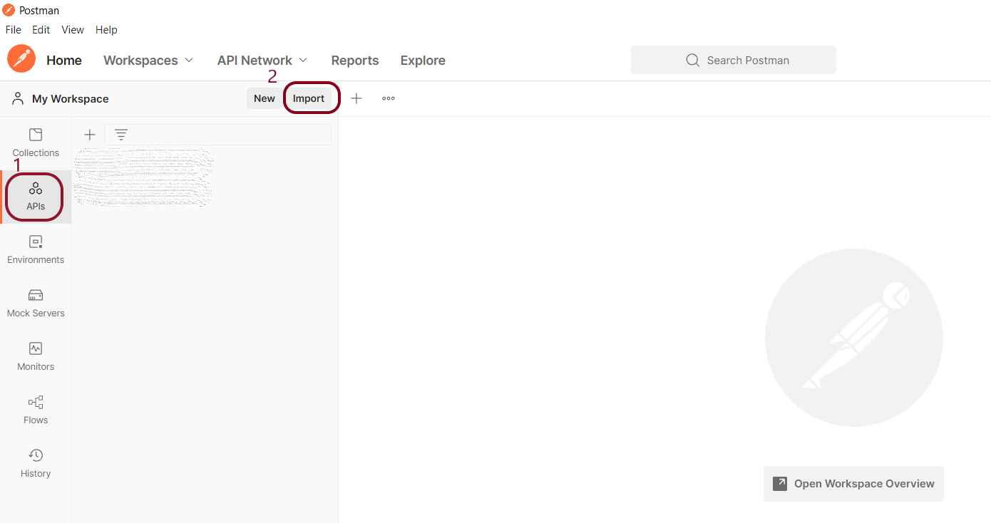
  - Step: 3
Click the Link button in the pop-up dialog box
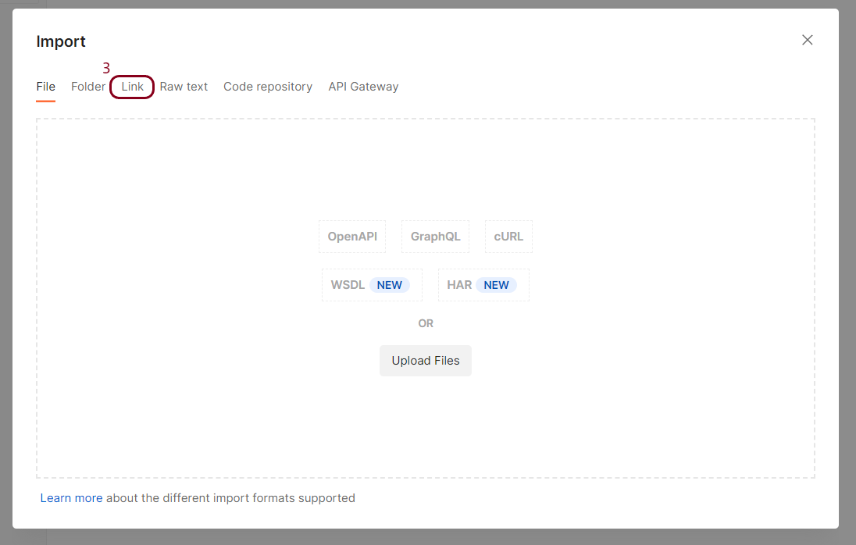
  - Steps: 4 and 5
Enter the below URL in the textbox and click Continue
https://cweb.dnbtanzania.com/TanWebsite/Services/LiveRequestService.svc?wsdl
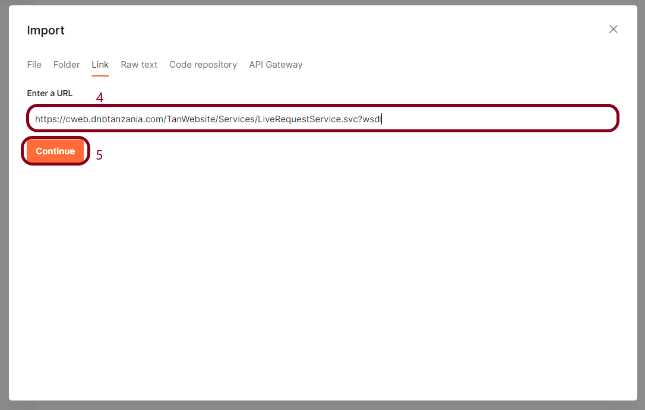
  - Step: 6
Click the import button as shown below
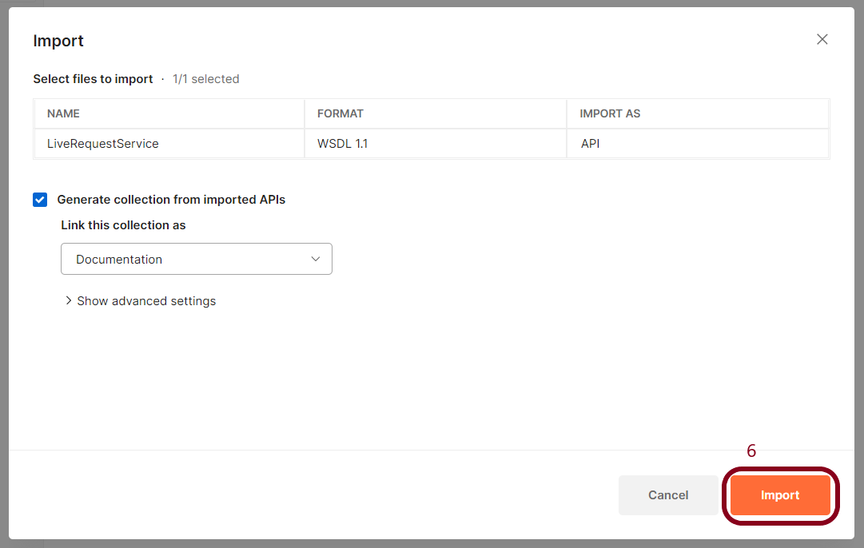

  - Step: 7
Close this pop-up dialog to proceed further.
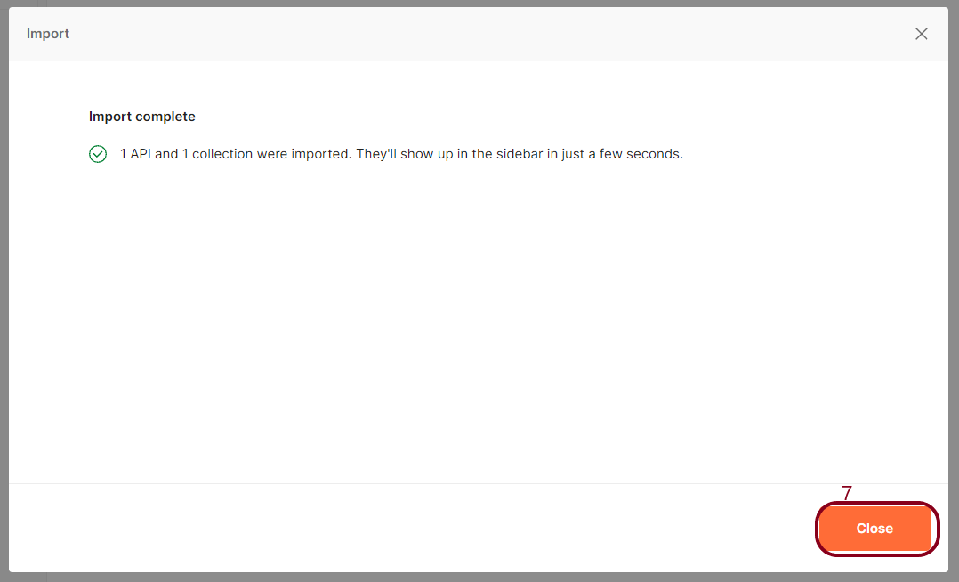
  - Step: 8
The step-6 will create the tree structure as highlighted below. Select the GetLiveCIR
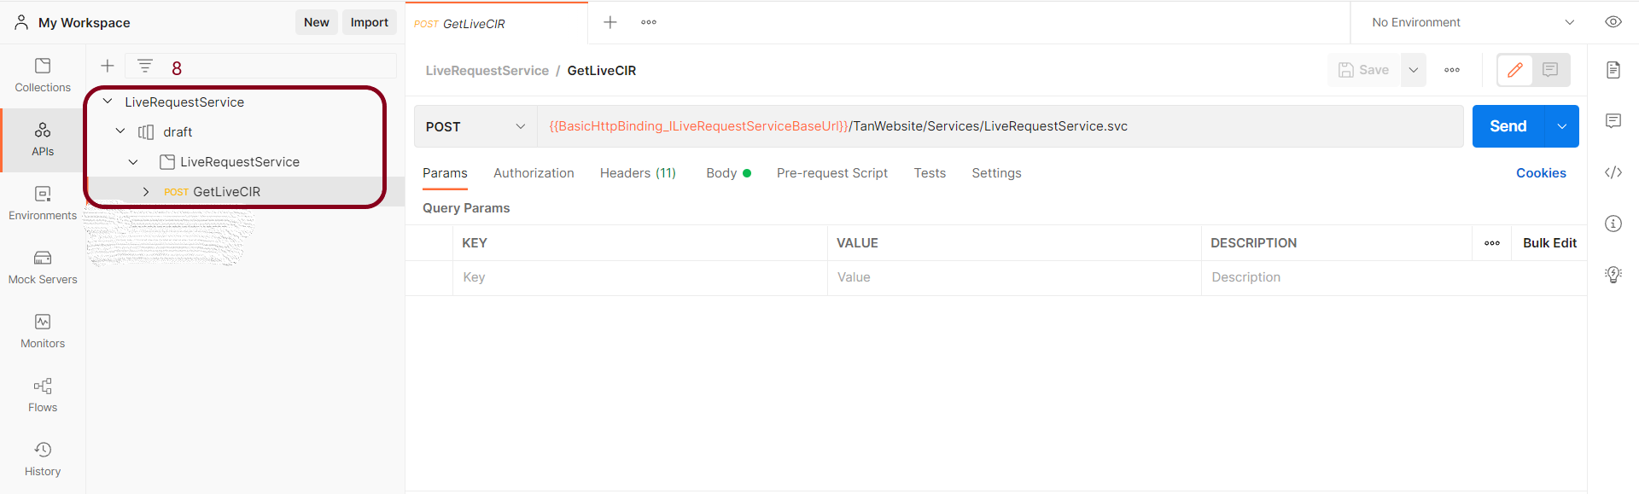

  - Step: 9
Select the body tab and clear its contents.
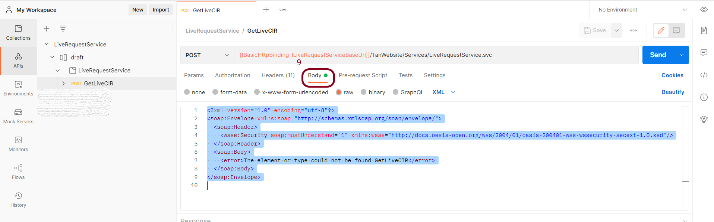
  - Step: 10
Replace the contents in the body tab with the below request payload
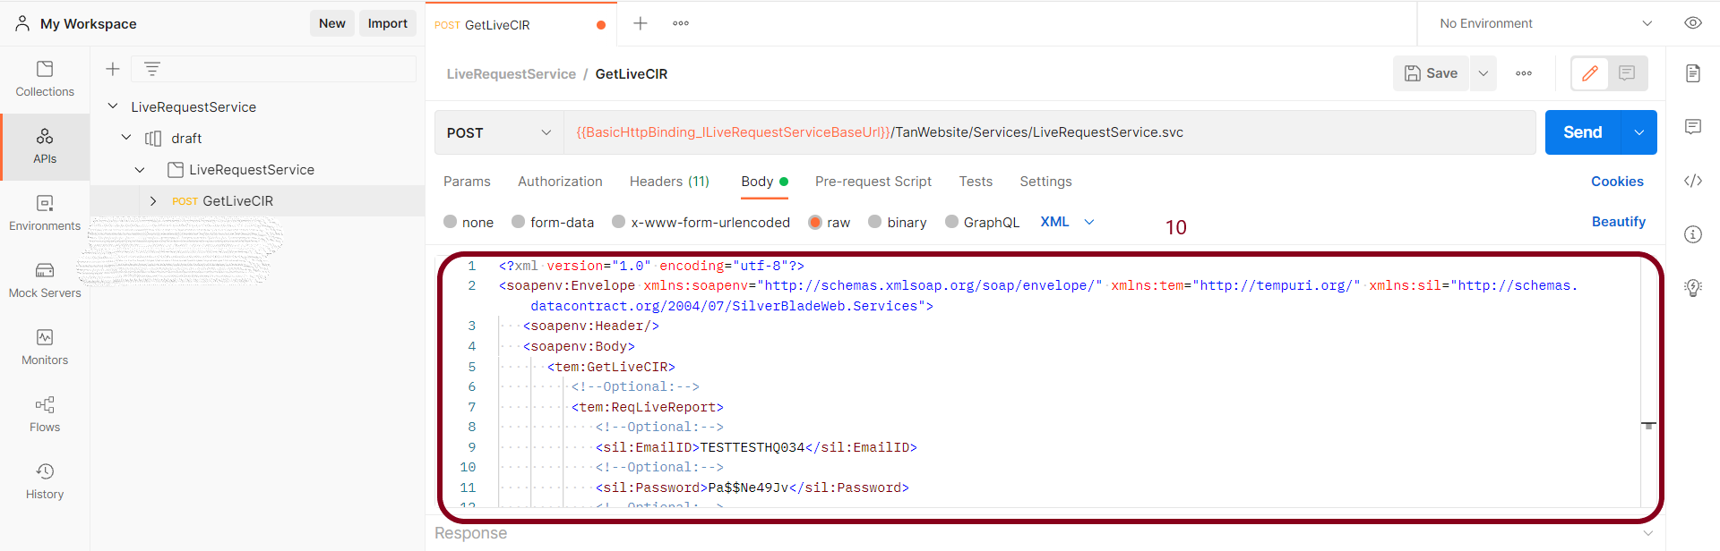

Request Payload
<?xml version="1.0" encoding="utf-8"?>
<soapenv:Envelope xmlns:soapenv="http://schemas.xmlsoap.org/soap/envelope/" xmlns:tem="http://tempuri.org/" xmlns:sil="http://schemas.datacontract.org/2004/07/SilverBladeWeb.Services">
<soapenv:Header/>
<soapenv:Body>
<tem:GetLiveCIR>
<!--Optional:-->
<tem:ReqLiveReport>
<!--Optional:-->
<sil:EmailID>TESTTESTHQ034</sil:EmailID>
<!--Optional:-->
<sil:Password>Pa$$Ne49Jv</sil:Password>
<!--Optional:-->
<sil:RequestXML><![CDATA[<REQUEST REQUEST_ID="1">
<REQUEST_PARAMETERS>
<REPORT_PARAMETERS REPORT_ID="14616" SUBJECT_TYPE="1" RESPONSE_TYPE="1" />
<PURPOSE_OF_INQUIRY CODE="1" />
<APPLICATION CURRENCY="" AMOUNT="" TYPEOFCREDITFACILITY="" REFERENCENUMBER="" />
</REQUEST_PARAMETERS>
<SEARCH_PARAMETERS>
<NAME>JOASHI YUDA KINYAMAGOHA</NAME>
<IDENTIFIER_NUMBER>46157126</IDENTIFIER_NUMBER>
<MOBILE>
</MOBILE>
<SURROGATES>
<NATIONALITY>TZ</NATIONALITY>
<DATEOFBIRTH>4-Mar-1989</DATEOFBIRTH>
</SURROGATES>
<ACCOUNTNUMBER>
</ACCOUNTNUMBER>
<CUSTOMERID>
</CUSTOMERID>
</SEARCH_PARAMETERS>
</REQUEST>]]></sil:RequestXML>
</tem:ReqLiveReport>
</tem:GetLiveCIR>
</soapenv:Body>
</soapenv:Envelope>

  - Step: 11
Select the Headers tab
  - Step: 12
And make sure these headers same as shown in the picture
  - Step: 13
And click the send button to send the request.
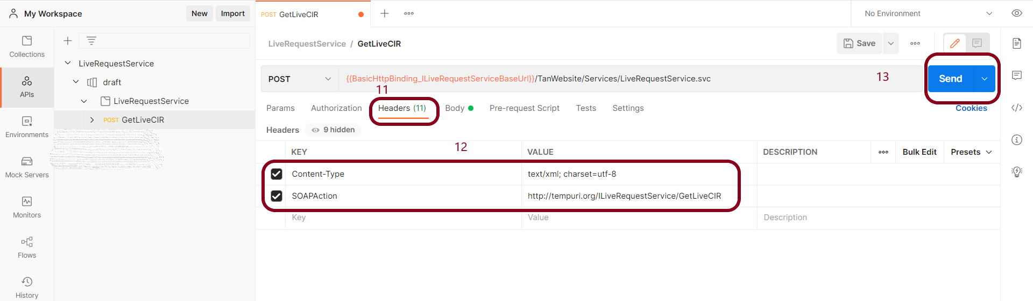

  - Step: 13
The response will be populated in the response area as shown in the below picture.
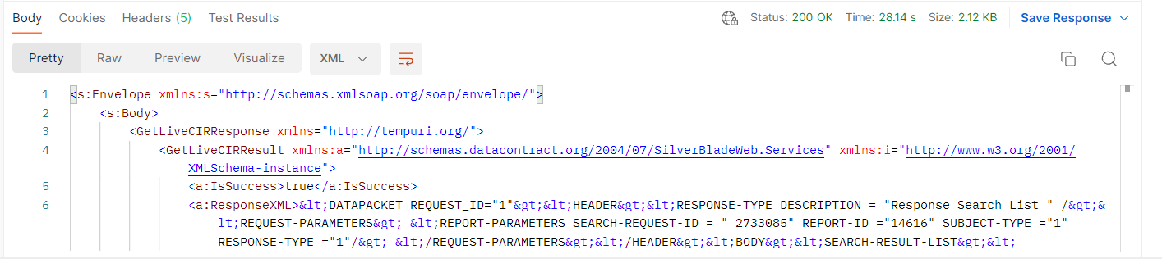

Live Request Response:
<s:Envelope xmlns:s="http://schemas.xmlsoap.org/soap/envelope/">
<s:Body>
<GetLiveCIRResponse xmlns="http://tempuri.org/">
<GetLiveCIRResult xmlns:a="http://schemas.datacontract.org/2004/07/SilverBladeWeb.Services" xmlns:i="http://www.w3.org/2001/XMLSchema-instance">
<a:IsSuccess>true</a:IsSuccess>
<a:ResponseXML>&lt;DATAPACKET REQUEST_ID="1"&gt;&lt;HEADER&gt;&lt;RESPONSE-TYPE DESCRIPTION = "Response Search List " /&gt;&lt;REQUEST-PARAMETERS&gt; &lt;REPORT-PARAMETERS SEARCH-REQUEST-ID = " 2733085" REPORT-ID ="14616" SUBJECT-TYPE ="1" RESPONSE-TYPE ="1"/&gt; &lt;/REQUEST-PARAMETERS&gt;&lt;/HEADER&gt;&lt;BODY&gt;&lt;SEARCH-RESULT-LIST&gt;&lt;SEARCH-RESULT-ITEM ENTITY-KEY ="150427" NAME = "JOASH YUDA KINYAMAGOHA KINYAMAGOHA"&gt;&lt;DOB&gt;02-Feb-1968&lt;/DOB&gt;&lt;GENDER&gt;Male&lt;/GENDER&gt;&lt;NATIONALITY&gt;TANZANIA, UNITED REPUBLIC OF&lt;/NATIONALITY&gt;&lt;IDENTIFIER-TYPE&gt;Voter registration number&lt;/IDENTIFIER-TYPE&gt;&lt;IDENTIFIER-NUMBER&gt;46157126&lt;/IDENTIFIER-NUMBER&gt;&lt;ADDRESS&gt;, BOX 12701 DSM, CITYTOWNVILLAGE.BOX 12701 DSM, Temeke, Dar_Es_Salaam&lt;/ADDRESS&gt;&lt;MOBILE-NUMBER&gt;+255659739996&lt;/MOBILE-NUMBER&gt;&lt;MATCHED-PARAMETER&gt;ID&lt;/MATCHED-PARAMETER&gt; &lt;SEARCHSCORE&gt;89&lt;/SEARCHSCORE&gt;&lt;/SEARCH-RESULT-ITEM&gt;&lt;SEARCH-RESULT-ITEM ENTITY-KEY ="718" NAME = "JOASHI YUDA KINYAMAGOHA KINYAMAGOHA"&gt;&lt;DOB&gt;12-Feb-1968&lt;/DOB&gt;&lt;GENDER&gt;Male&lt;/GENDER&gt;&lt;NATIONALITY&gt;TANZANIA, UNITED REPUBLIC OF&lt;/NATIONALITY&gt;&lt;IDENTIFIER-TYPE&gt;Voter registration number&lt;/IDENTIFIER-TYPE&gt;&lt;IDENTIFIER-NUMBER&gt;46157126&lt;/IDENTIFIER-NUMBER&gt;&lt;ADDRESS&gt;, KEKO, Temeke, Dar_Es_Salaam&lt;/ADDRESS&gt;&lt;MOBILE-NUMBER&gt;0000000000&lt;/MOBILE-NUMBER&gt;&lt;MATCHED-PARAMETER&gt;ID&lt;/MATCHED-PARAMETER&gt; &lt;SEARCHSCORE&gt;89&lt;/SEARCHSCORE&gt;&lt;/SEARCH-RESULT-ITEM&gt;&lt;/SEARCH-RESULT-LIST&gt;&lt;/BODY&gt;&lt;/DATAPACKET&gt;</a:ResponseXML>
</GetLiveCIRResult>
</GetLiveCIRResponse>
</s:Body>
</s:Envelope>

